**Exp No:** 10 **Date:** 19/10/2020

**Name:** Swetha Saseendran

**Reg No:** 185001183

DISPLAY A STRING

## Aim:

To program and execute case conversions using 8086 microprocessor using DOSBOX.

# Programs:

## Algorithm:

* Initialise message in data segment.
* Use DOS function and offset of message to output the string.
* Terminate the program.

|  |  |
| --- | --- |
| **PROGRAM** | **COMMENT** |
| **DATA SEGMENT**  MESSAGE DB "message$"  **DATA ENDS**  **CODE SEGMENT**  **ASSUME** CS:CODE,DS:DATA  **START:**  MOV AX,DATA  MOV DS,AX  MOV AH,9  MOV DX,OFFSET MESSAGE  INT 21H ;  MOV AH,4CH  INT 21H  **CODE ENDS**  **END START** | INITIALISE THE DATA SEGMENT  DOS FUNCTION #9  OFFSET OF THE STRING  DISPLAY IT  TERMINATE THE PROGRAM |

## Unassembled Code:

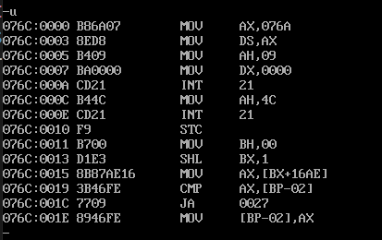

## Snapshot of sample input and output:

**INPUT:**

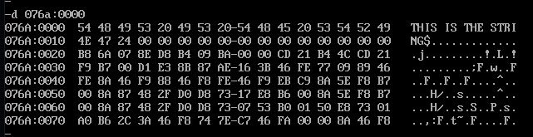

**OUTPUT:**

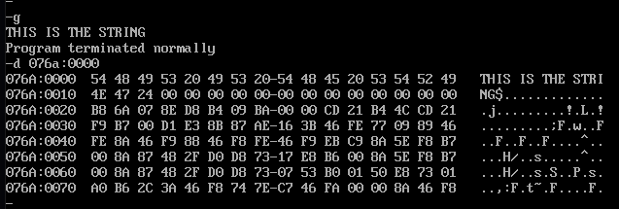

# Result:

The assembly level programs were written to perform the above specified system operations and the output was verified.